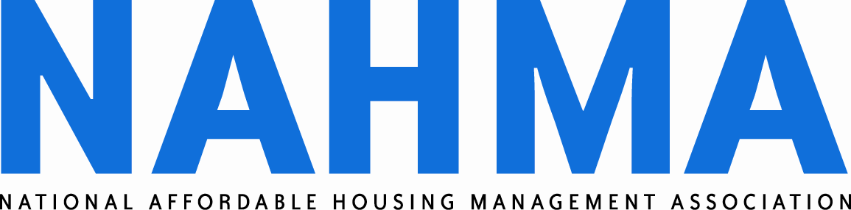
400 North Columbus Street, Suite 203
Alexandria, VA 22314
(703) 683-8630
(703) 683-8634 FAX
www.nahma.org

January 25, 2006

Ms. Susan Reaman
Branch Chief
Branch 5 (CC:PSI:B05)
Internal Revenue Service
1111 Constitution Avenue
Washington, DC 20224

Dear Susan:

This letter comes as a follow-up to our January 19 discussion about Section 42 properties damaged by recent hurricanes in the Gulf Coast. This letter comes to request that the Internal Revenue Service (IRS) issue a revenue procedure which extends the temporary relief periods provided in Rev. Proc. 95-28 for Section 42 properties in major disaster areas affected by Hurricanes Katrina, Rita and Wilma. Of particular interest to our members is an extension of the recapture relief. We agree that the IRS has authority to extend these periods, and we believe it is in the public interest to do so.
The National Affordable Housing Management Association (NAHMA) represents owners, management agents and other individuals involved in federal affordable multifamily housing rental programs, including the Section 42 Low Income Housing Tax Credit. A number of our members with properties in the Gulf Coast have voiced concerns that the 24-month temporary relief from recapture and loss of credit provided in Rev. Proc. 95-28 section 7.01 will not allow sufficient time to bring low-income units back online. We respectfully request that this relief be extended to 48 months, with an option for the IRS to provide additional extensions upon expiration.
NAHMA’s request is based on reports from our Gulf Coast members about the extent of damage to their properties and the obstacles to restoring the housing. Some examples of problems that must be addressed in order to restore the Gulf Coast properties include:
- Federal flood levels are not re-established to allow a decision on whether rebuilding is feasible;
- Uncertainty of New Orleans infrastructure rebuilding and flood proofing does not permit a rational decision regarding re-investment;
- Financing for repairs and restoration is scarce in flood prone areas;
- Insurance coverage unavailable or not available in sufficient amounts at reasonable cost;
- Physical damage to the buildings or complete demolition;
- Legal issues with regard to right of re-entry and disposition of tenant possessions;
- Difficulty in making mortgage payments; and
- High vacancy rates.

Considering the logistical and financial difficulties Section 42 properties in the Gulf Coast will endure for years to come, it is unclear how many units could be brought back online within the 24 month temporary relief period. The loss of credits or recapture of previously claimed credits would devastate rebuilding efforts, and would also have a chilling effect on further private sector investment in these properties. We strongly believe extending the temporary relief period an additional two years, with the possibility of additional extensions, is in the best interest of the Section 42 program, owners, investors, and the tenants.

Thank you for your consideration of this request. Please feel free to contact me or Michelle Kitchen for further information. We can be reached at 703-683-8630.

Sincerely,

Kris Cook, CAE
Executive Director

cc: Eric Solomon
Paul Handleman
Sharon Kay

