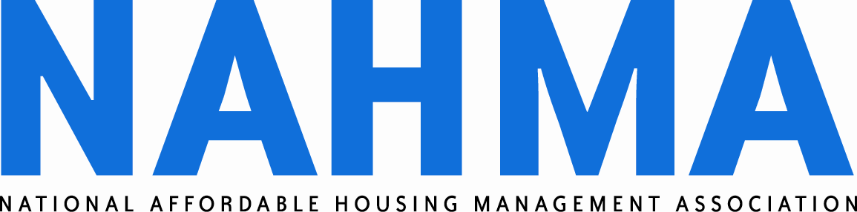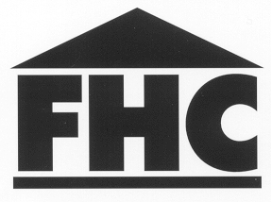

Approved Fair Housing Instructors

Helena Padellaro
67 Burton Street
Brighton, MA 02135
(617)306-1612
Hpadellaro@comcast.net

Anita Moseman
Monfric Realty, Inc.
1156 Hill Avenue
Grand Junction, CO 81501
(970) 434-9719 Ext. 17
amoseman1@aol.com

Larry Sisson
TESCO Properties, Inc.
2171 Judicial Drive, #200
Germantown, TN 38138
(901) 759-7277
lsisson@tescoproperties.com

Laurie Fritz
KHRC
611 S. Kansas Avenue,
Suite 300
Topeka, KS 66603
(785) 217-2055
lfritz@kshousingcorp.org

Tim Herrman
Good Samaritan Society
8480 Maurer Rd. #1034
Lenexa, KS 66219
(605) 368-0647
therrman@good-sam.com

Debbie Piltch
Maloney Properties, Inc.
27 Mica Lane #301
Wellesley, MA 02481
(781) 943-0200
piltchassociates@gmail.com

Heather Staggs
Star Momentum Training & Consulting, LLC
6873 Sapphire Pointe Blvd.
Castle Rock, CO 80108
(303) 593-0305
heather@star-momentum.com

Gwen Volk
Infocus, Inc.
P.O. Box 1965
Marshall, TX 75671
(903)938-2605
gwenvolk@gwenvolk.com

(List date: 06/07/2019)

